**DATA LABELLING**

[**https://24x7offshoring.com/**](https://24x7offshoring.com/)

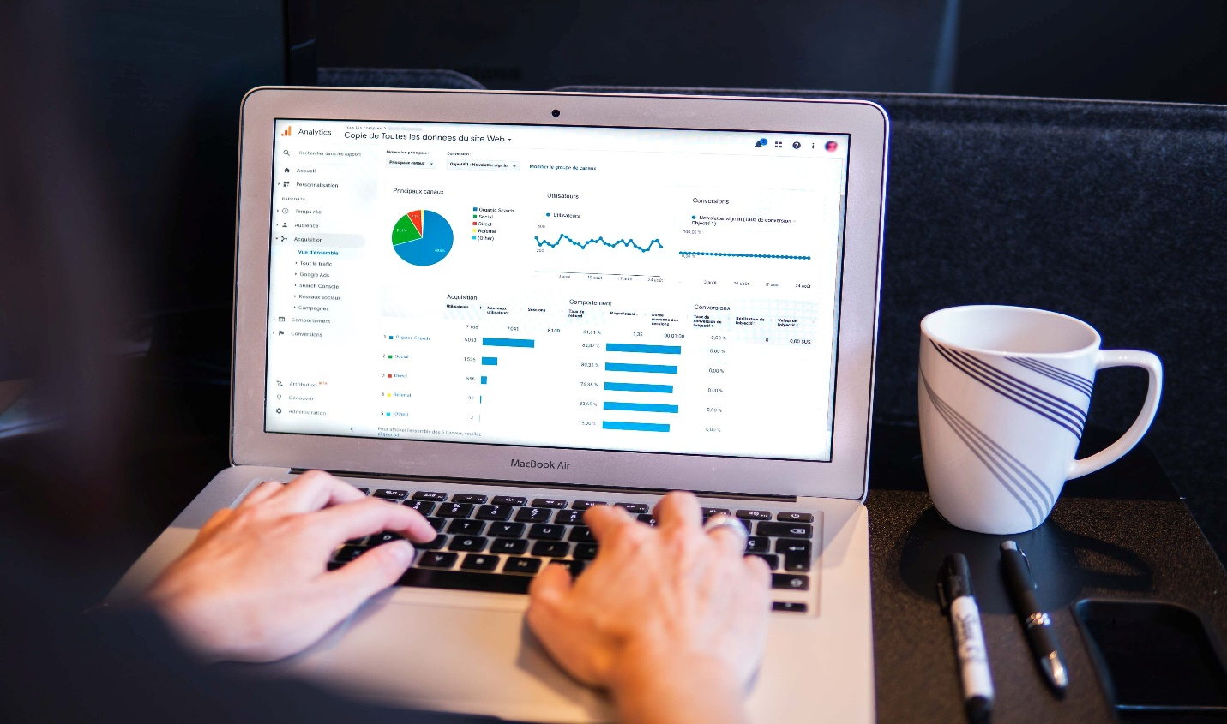 [**http://24x7outsourcing.com/**](http://24x7outsourcing.com/)

**What is Data Labeling?**

Man-made consciousness (AI) is just however great as the information it seems to be prepared with.

All things considered, 80% of the time spent on an AI project is fighting preparing information, including information naming.

When assembling an AI model, you'll start with a huge measure of unlabeled information.

**Instructions to Get Labeled Data**

Information names should be exceptionally exact to show your model to make right forecasts.

The information naming cycle requires a few stages to guarantee quality and precision.

**Information Labeling Approaches**

It's critical to choose the suitable information naming methodology for your association, as this is the progression that requires the best speculation of time and assets.

Information marking should be possible utilizing various strategies (or mix of techniques), which include:

**In-house:**

Use existing staff and assets. While you'll have more power over the outcomes, this strategy can be tedious and costly, particularly in the event that you need to recruit and prepare annotators without any preparation.

**Rethinking:**

Hire transitory specialists to name information. You'll have the option to assess the abilities of these workers for hire however will have less power over the work process association.

**Publicly supporting:**

You may pick rather to publicly support your information naming necessities utilizing a believed outsider information accomplice, an ideal choice on the off chance that you don't have the assets inside.

**By machine:**

Data marking should likewise be possible by machine.

ML-helped information naming ought to be thought of, particularly when preparing information should be set up at scale.

It can likewise be utilized for computerizing business measures that require information classification.

**Quality Assurance**

Quality confirmation (QA) is a frequently disregarded yet basic part to the information naming cycle.

Make certain to have quality checks set up in case you're overseeing information planning in house.

In case you're working with an information accomplice, they'll have a QA cycle effectively set up.

**Train and Test**

Whenever you have named information for preparing and it has passed QA, the time has come to prepare your AI model utilizing that information.

From that point, test it on another arrangement of unlabeled information to check whether the expectations it makes are precise.

You'll have various assumptions for exactness relying upon what the necessities of your model are.

On the off chance that your model is preparing radiology pictures to recognize disease, the exactness level may should be higher than a model that is being utilized to distinguish items in a web based shopping experience, as one could involve life and demise.

Set your certainty edge as needs be.

**Use Human-on the up and up**

When testing your information, people ought to be associated with the cycle to give ground truth checking.

Using human-on the up and up permits you to watch that your model is making the correct forecasts, distinguish holes in the preparation information, offer input to the model, and retrain it depending on the situation when low certainty or inaccurate expectations are made.

**Scale**

Make adaptable information naming cycles that empower you to scale.

Hope to emphasize on these cycles as your requirements and use cases advance.

**DATA LABELLING**

[**https://24x7offshoring.com/**](https://24x7offshoring.com/)

[**http://24x7outsourcing.com/**](http://24x7outsourcing.com/)